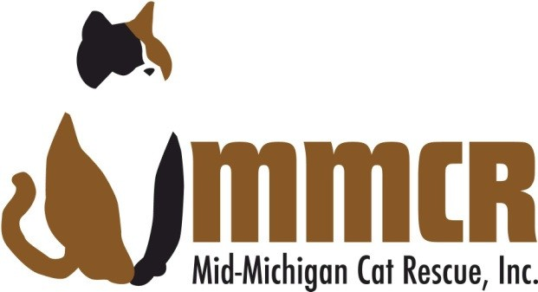
Volunteer Application
Make a copy for a friend!

Mid-Michigan Cat Rescue is in need of volunteers for a variety of activities. This form is meant to assist us and you in determining your areas of interest. No experience is needed and MMCR does have training programs for almost all activities you could be interested in helping with. Email your completed application to Mid-Michigan Cat Rescue, at volunteer@midmichigancatrescue.org

Name: Are you at least 18 years old?
Street Address:
City: State: Zip:
Phone: (cell) (home)
E-mail address:
When is the best time to reach you:
Do you have any special skills or abilities that you feel MMCR could utilize?

Professional services such as accounting, publicity, marketing or advertising
Fundraising
Collecting donations from locally placed donation cannisters
Website and social networking sites, i.e., Facebook, Twitter, etc.
Assisting with adoption events, special events or networking events
Clerical, correspondence and internet research
Help at main foster home/headquarters
Sewing, knitting, gardening, woodworking and crafting
Newsletter, grant writing
Shelter repair and maintenance
Educational program assistance in elementary/middle schools
Petsmart Evening Duties-30 mins. once a week
Assistance with feral cat management program (T,N,R)
Foster care or kitten socialization

Are you willing to have a home check if you are interested in fostering? Yes No
Have you ever been convicted of a crime? Yes No
What days and times work best for you?

SIGNED: DATE:
Typing your name in the field above acts as your signature

